ENRON EUROPE
SUPPORT OPERATIONS & APPROVAL PLAN

NEW OPERATION NAME: EWZ JOINT VENTURE

Counterparty (where relevant): EWZ  Business Unit: Continental Power  Business Unit Originator: Peter Heydeker  Support Team Co-ordinator: Naomi Connell  Date Operations Approval Completed: |  | Investment Set-up Other  Fair Value New Office Land sites  X Joint Venture X New Business within Financing/refinancing  Subsidiary existing office Asset development  Other
Other forms of approval : | X DASH |  | X CACS | None

PROJECT DESCRIPTION
Strategy
A successful cooperative arrangement has existed for a number of years between EWZ and Enron. In the context of the increasing liberalization of the electricity market, this cooperation is to be institutionalized and further strengthened through the formation of a joint venture: EWZ is interested in this opportunity for the following reasons:
- In the liberalized market, the unbundled Generation and Sales divisions of EWZ are to concentrate entirely on the operation of power plants at minimal cost for the former and connection with end-users with the highest possible sales margins for the latter. As Profit Centers, Generation and Sales are no longer to bear substantial market risks and are to liquidate their long and short positions for this purpose by means of hedging through an institution (the jv). The institution will thus accept all energy of the Generation Profit Center and deliver all supply energy to the Market and Customers Profit Center. The joint venture will assume these tasks within the framework of comprehensive portfolio and risk management.
- EWZ wishes to ensure the professionalism of its wholesale activities without having to develop the expensive infrastructure necessary for wholesale on its own. The marketing of the net long positions of EWZ's power plants, which will continue for the foreseeable future, is of particular importance in this regard. Through the joint venture, EWZ will receive direct access to Enron's inter-regional market knowledge and optimization instruments, which are necessary for maximizing the production value of the power plants.

The upside for Enron is:
- Benefit from EWZ contacts and market strength to rapidly infiltrate the Swiss market
- further develop the market-oriented optimization of power plants and sale of power plant flexibility. This can be achieved through the joint venture with EWZ without investing in the infrastructure which is particularly necessary in intra-day trading.
- In addition, this will considerably increase the opportunities for concluding hydro-deals with third-party municipal utilities and regional suppliers like those concluded last year with a number of Swiss counterparts.

Operations
The JV will be staffed by commercial and logistics teams on secondment from Enron and EWZ. A management team will be set up and act within the JV operating framework rules. Traders based in London’s continental power team will provide daily prices and volume limits to the JV commercial team who will set up the deals and enter data into Enpower. The London traders will have direct responsibility for this sub-section of the Continental power book and will manage the out of balance position appropriately. Two services agreements will be set up with Enron (middle office) and with EWZ (back office) such that no support staff will be directly employed by the jv, but will be managed through the normal controls infrastructures in Enron for middle office (documentation, settlements, risk management, cash management, credit) and in EWZ for back office (financial accounting, local tax compliance, local statutory requirements, local regulatory and company secretarial).

PROJECT STATS

Commercial team to provide NPV of deal

KEY POINTS FOR MANAGEMENT

- The model applied is similar to that of the “Agency” model used within Metals. I.e. the full trading responsibility is retained in the central trading location, with the “agency traders” receiving specific price ranges and volumes on a daily basis from the traders. The “agency traders” are able to commit the JV within those limits over the phone on specific sales, however, in order to execute a transaction, they will be obliged to ensure deal capture as the documentation and settlements teams are based in the central location.

BUDGET FOR SET-UP /INTEGRATION
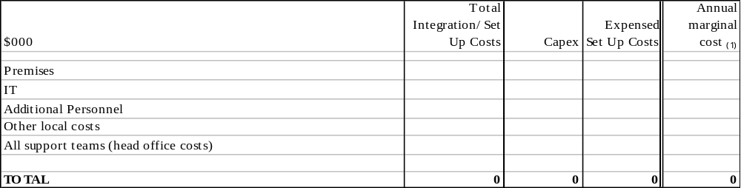
(1) Marginal cost should include the general management cost to Enron in taking on this new business as well as direct costs.

COMMERCIAL REQUIREMENTS/STRATEGY

The commercial team require an even structure between Enron and EWZ – the cost of support activities recharged to the JV should be appropriate and supportable by time charge or similar mechanism.

KEY RISKS TO BE MANAGED ON AN ONGOING BASIS

Commercial | Position management  All non-standard deals to go through the CACS process
Tax | International tax advice to be provided by Enron, but local tax compliance and advice to be provided by EWZ – ensure good liaison with EWZ tax department and receipt of all tax filings done locally by EWZ.  Approve CACS for all non-standard deals
Transaction Support | Maximisation of value in the deals – ongoing support  Approve CACS for all non-standard deals
Middle Office | Ensure appropriate and efficient procedures to support this new venture. In particular good communication channels and respect of SLAs are essential  Take responsibility for the trading controls over this office and in particular provide good segregation of duties. The strict and appropriate application of the “agency” model is essential in order to ensure deal capture.  Regular presence in Switzerland to ensure the application of middle office controls will be essential. It is not currently envisaged that a Risk manager is permanently based in Switzerland, however this position should be reviewed regularly.  Approve CACS for all non-standard deals
Financial Operations | Ensure all accounting information is transferred between EWZ and Enron in a seamless manner. In particular, the JV will require the accounting information in local GAAP and not US GAAP.  Approve CACS for all non-standard deals
Regional Support | Provide regular monitoring of the Swiss JV Agency office status
Global Finance | Initial Investment of $12m reducing to $6m when the Swiss partner comes on board
Cash Management | Provide read only access to the JV bank account by EWZ  Ensure good communication channels and respect of SLAs.  Enron’s opening position is to manage the bank accounts directly – this is likely to be an ongoing point of discussion with EWZ
Legal | Ensure that Operating Guidelines allow for clear management and decision making structure  Ensure application of CACs process for all non-standard deals
HR | Monitor Enron secondees and provide appropriate support re personal tax and wage tax
Credit

SUPPORT REQUIREMENTS (PRE OPERATION) SUMMARY
Admin / Property | The Enron Zurich office will be refitted to enable some separation between the JV and the Enron origination team and to increase the Coms room
IT operations | The current IT build is of lowest spec. Additional equipment such as trading turrets and voice recording will be required.
IT Systems | The JV will use the Enpower front-end over the intranet. Access will be restricted to very precise areas for EWZ personnel by use of password. Standard Windows package will also be available with no access to middle or back office systems from Switzerland.
Tax
Financial Operations | Design processes to ensure the accurate transfer of information between Enron and EWZ and discuss with EWZ accounting team. EWZ are on SAP so this should be achieved in an automated manner, however complexities of GAAP to be worked through.
Risk Management / Middle office | Ensure appropriate processes set up to enable Risk management to control all operations. Documentation and Settlements will need to co-ordinate with JV team on a daily basis and communication channels should be set up and SLAs set up.
Cash Management | Set up bank accounts
Global Finance | Determine funding mechanism
Legal | Preparation of JV agreement, management guidelines and service agreements. Set up company.
HR | N/A
Credit | Ensure mechanism for veto of particular counterparties not acceptable by Enron. Set up CAS appropriately. Enron only own 50% of the credit risk but credit will need to monitor 100% of the credit risk as part of their service contract to the JV.
The above key requirements must be satisfied as part of implementation.

OTHER COMMENTS:

REQUIRED  APPROVALS |  | Name |  | Signature |  | Date
Business Originator |  | Peter Heydeker
Regional Support |  | Naomi Connell
Middle Office |  | James New
EEL Executive |  | Michael Brown

CC’d for INPUT & INFO

Melissa Allen – Transaction Support /Fin Ops
Claire Wright – Transaction Support/Fin Ops
Mike Jordan – Middle Office
Coralie Evans – Continental Power Risk Management
Gail Hill – Documentation
Ian Sloman – Settlements
Dirk Remuss – Tax
Michael Schuh – Legal
Stephan Diescher - HR
Ralph Jaeger – Regional Controller, German Speaking Region
Barry Sangster – IT operations
Neil Austin – Corporate Real Estate
Anne Hicks – Cash Management
Suryan Wirya Simunovic – RAC Underwriting
Olivier Herbelot – RAC Underwriting
Paul Chivers – Global Finance
David Williams – Regional IT Systems
Tim Davies – Credit
Fernley Dyson – CAO
Peter Kreuzberg - Structuring
Martin Bloch - Commercial

